Design 1:

Logo:

Colour:

Description:

Shape:

Rollover version

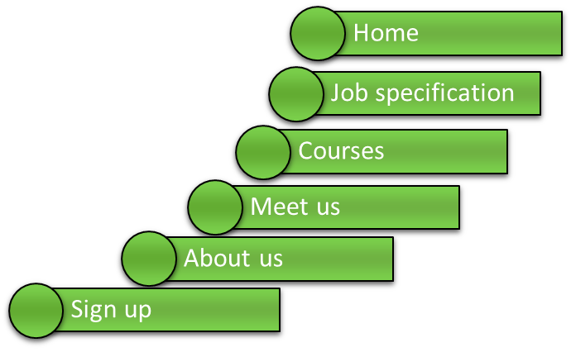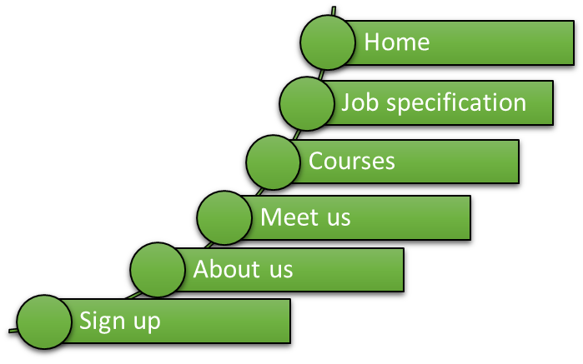

Navigation

Colour:

Description:

Shape:

Button placement:

Background:

Colour:

Description: